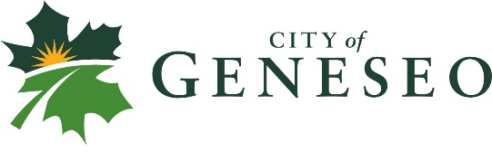
2020 HSA DEDUCTIBLE REIMBURSEMENT
I, _________________________________, City of Geneseo City Employee, have reached my full HSA deductible of $2,700 (single) or $5,400 (employee + spouse, employee + children, & family). I am requesting that the difference of $200_____or $400_____ to cover the added cost above my previous deductible, which was $2,500 or $5,000. I am including a copy of my 2020 Spending Summary from United Healthcare that shows I have met the deductible/s.

PLEASE CHOOSE ONE:
__Please place the funds in my HSA account
(This option is recommended unless you are going to reach the maximum annual funds allowed into your HSA account)
__Please provide me an accounts payable check
(I understand that I will be reimbursed on an accounts payable check following the next City Council meeting)

Date: _________________
Employee Signature___________________________

In order to receive this reimbursement for deductible year 2020, this form must be turned in by March 1, 2021.

