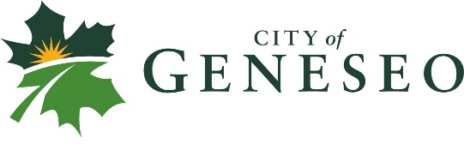
HSA DEDUCTIBLE REIMBURSEMENT
I, _________________________________, City of Geneseo City Employee, have reached my full medical plan deductible (either single or family) in the current year, above and beyond the $2,800 (single)/$5,600 (family) amounts agreed to be funded directly by the employee. I am requesting the difference of $_____. I am including a copy of my spending summary from our Medical Provider that shows I have met the deductible/s.

PLEASE CHOOSE ONE:
__Please place the funds in my HSA account
(This option is recommended unless you are going to reach the maximum annual funds allowed into your HSA account)
__Please provide me an accounts payable check
(I understand that I will be reimbursed on an accounts payable check following the next City Council meeting)

Date: _________________
Employee Signature___________________________

In order to receive the reimbursement for any calendar year deductible, this form must be turned in by March 1st, the following year.

